The name of the identified app:

Gumen_variety1

The form of the pattern:：

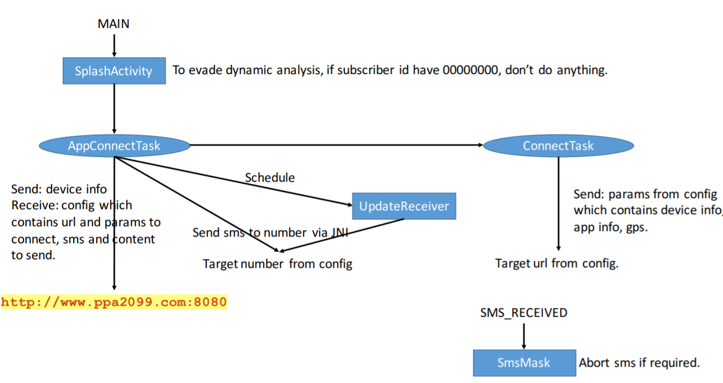

Name of Sample app：

单车神将

The name of this app:

TRIfA

For functional modules:：

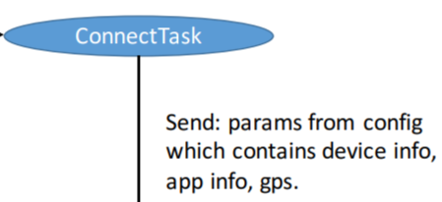

Corresponding to the key code in sample app：

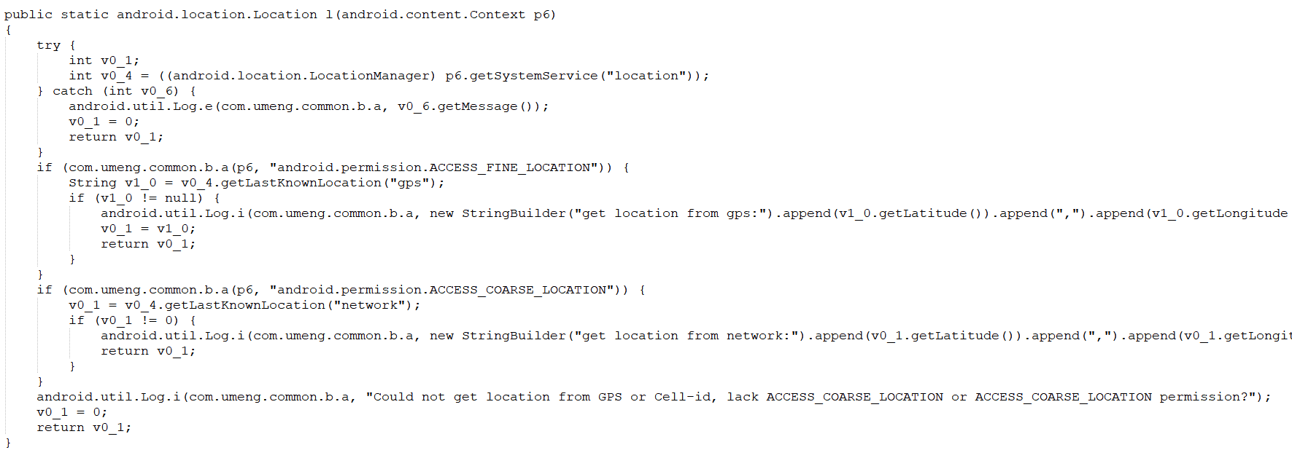

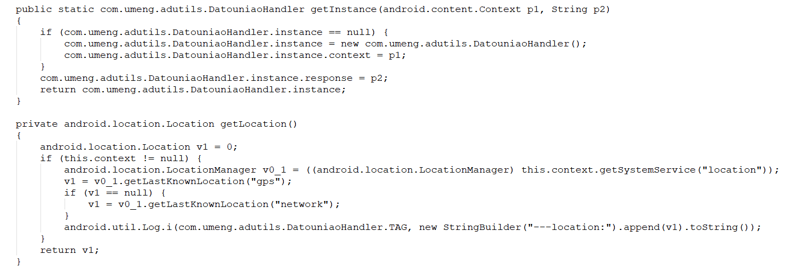

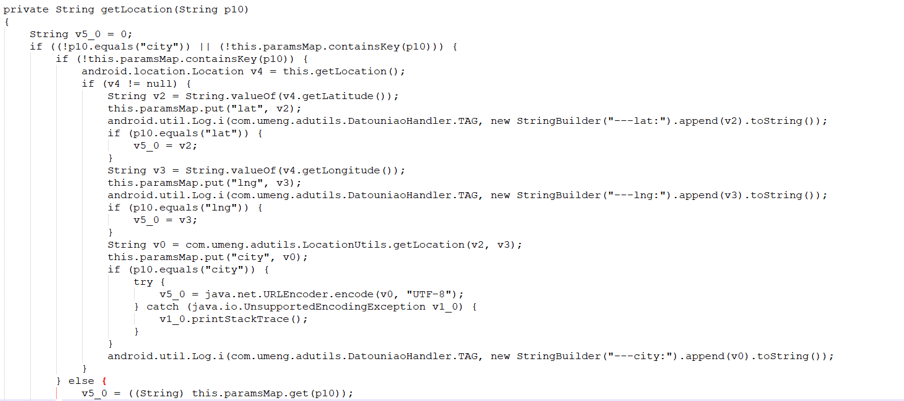

Corresponding to the key code in this app：

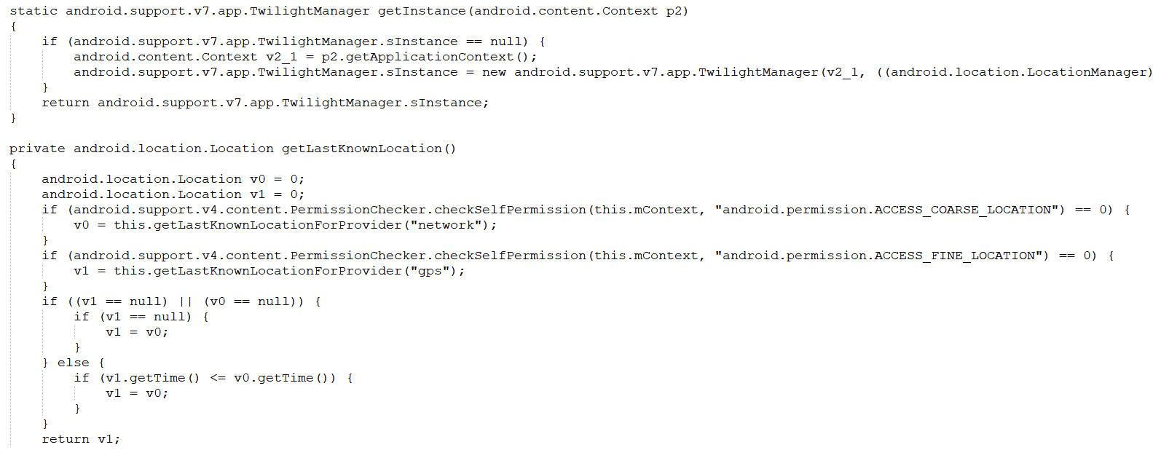

For functional modules：

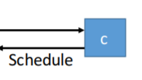

Corresponding to the key code in sample app：

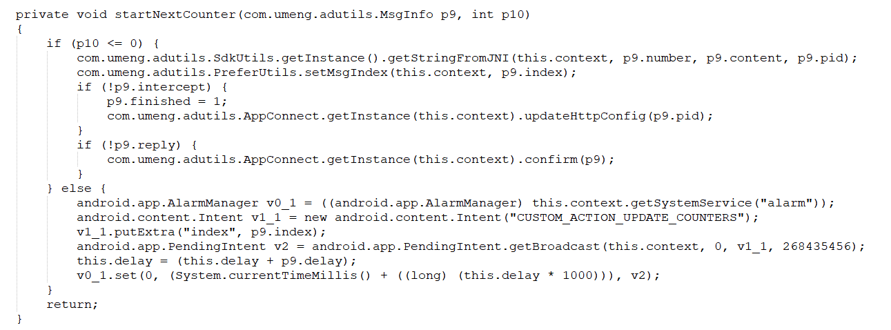

Corresponding to the key code in this app：

